Problem 3 – Bishop Path Finder
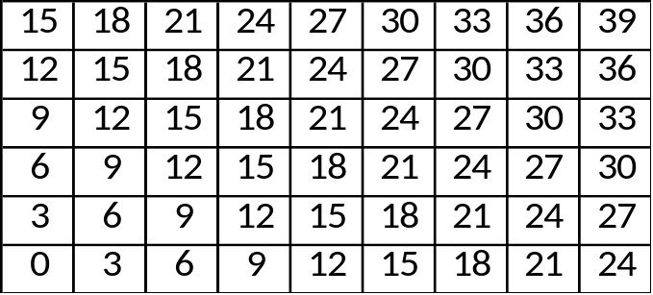
You are given a rectangular chessboard. The chessboard is filled with numbers as follows:
- The bottom left corner holds the value 0
- The next cell above holds value of 3, the next cell above holds of 6, etc…
- The second cell the bottom row holds a value of 3, the cell next to it holds a value of 6
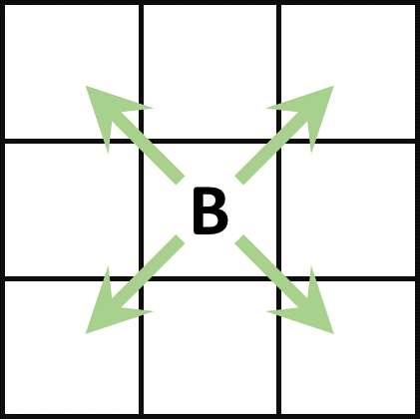
You have a bishop on the chessboard. The bishop can only move to the cells that are diagonally next to him. The possible directions are UP-RIGHT, DOWN-RIGHT, UP-LEFT and DOWN-LEFT.
Given that initially the bishop starts at the bottom left corner, a list of directions and how many moves the bishop is about to perform in each direction, calculate the sum of the cells that the bishop has to go through.
The value of each cell is calculated only once, i.e. if the bishop visits the same cell more than once, its value is added to the result only the first time (the value is collected).
If the bishop is about to perform K moves in the given direction, but there are less than K cells before the edge of the board, the bishop performs as many moves as are available and stops at the edge of the chessboard.
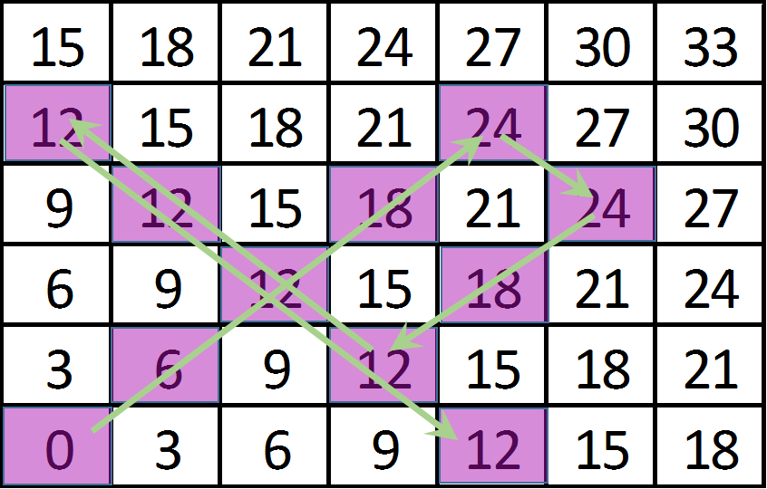
Example:
You are given a chessboard with size 6x7, and the directions and moves:
- 5 moves UP-RIGHT
- 2 moves DOWN-RIGHT
- 3 moves DOWN-LEFT
- 6 moves UP-LEFT
- 5 moves DOWN-RIGHT
The bishop collects values: 0, 6, 12, 18, 24, 24, 18, 12, 12, 12 and 12. Their sum is 150.

Input
The input data is given at the standard input, i.e. the console
On the first line you will find the dimensions of the chessboard R and C, separated with a space
On the second line you will find the number N, the number of directions and moves
On the next N lines you will find a string D and a number K, separated with a single space:
- D is the next direction of the bishop
- K is the number of moves to perform in this direction
The input will be valid, in the specified format, within the constraints given below. There is no need to check the input data explicitly.

Output
Print the sum of values from the path of the bishop

Constraints
- R will always be between 1 and 1000
- C will always be between 1 and 750
- N will always be between 1 and 1000
- K will always be between 1 and 1000
- D will always have one of the values RU, UR, LU, UL, DL, LD, RD or DR:
  - RU and UR mean UP-RIGHT
  - LU and UL mean UP-LEFT
  - DL and LD mean DOWN-LEFT
  - DR and RD mean DOWN-RIGHT
- Allowed working time for your program: 0.15 seconds.
- Allowed memory: 16 MB.

Example
Input | Output | Explanation
6 7  5  UR 5  RD 2  DL 3  LU 6  DR 5 | 150 | In the example
Input | Output | Explanation
2 2  10  UR 2  LD 100  DR 500  UL 500  UL 5  LD 120  RD 123  LU 321  UR 2  LD 100 | 6 | 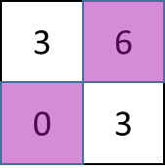  The only values that can be collected are 0 and 6, and they are collected only once
Input | Output | Explanation
3 3  4  UR 22  DL 2  DR 8  UL 75 | 30 | 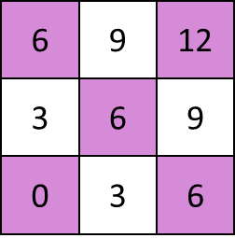  - Move UP-RIGHT, has only 3 moves and values 0, 6 and 12. All values are not yet collected so the bishop collects them  - Move DOWN-LEFT, has 2 moves and values 12 and 6. Both values are already collected, so the bishop collects nothing.  - Move DOWN-RIGHT, has only 2 moves and values 6 and 6. One of values is alread collected, so the bishop collects only 6.  - Move UP-LEFT, has only 3 moves and values 6, 6 and 6. Two of the values are already collected, so the bishop collects only 6.  The sum is: 0 + 6 + 12 + 6 + 6 = 30

